Evan Rixom

3/5/2025

SAT5424 Pop Health Info

**Architecture Development Part 4: Installation and Configuration of Hapi-FHIR Server**

Submission Requirements to be placed into one document (PDF or MS Word):  
1. Take a screenshot of the HAPI-FHIR server’s default web UI and submit it with your other lab  
materials. (5 points)

2. What command could you use to check the total, used, and free memory in system if you  
thought the HAPI-FHIR server was not running properly due to lack of memory? (5 points)

**Sudo docker stats or free -h**

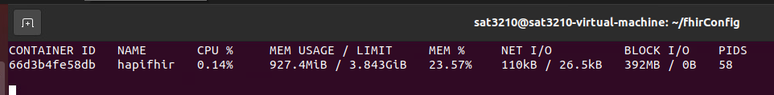

3. You've updated the firewall rules on your Ubuntu server and want to check if the port (say 8080)  
used by the HAPI-FHIR server is open. What command would you use? (5 points) **sudo ufw status**

  
4. If the HAPI-FHIR server fails to start, you want to ensure that there are no other processes  
occupying the default port (8080). What command should you use to check if the port 8080 is  
currently in use? (5 points) **sudo ss -tulnp | grep :8080**

  
Note: Include a screenshot for your results in question 2,3,4 above

**Bonus Section (2 points)**  
1. Customize the default HAPI-FHIR UI (web page) so that it says, “Upper Peninsula Health Care  
Network” instead of “Company Name” and “The Health Information Exchange for the Upper  
Peninsula“ instead of “Your Sample Text Here”. Submit a screen shot to verify your work. (2 points)

